#Deloitte_Interview

Round 1: (Technical)

1. Explain about yourself and your roles and responsibilities.

2. Write Java code to reverse a string while preserving the whitespace.

3. Given an SQL table, find the second-largest salary of an employee.

4. Explain the concept of joins and list the different types of joins available.

5. What is LinkedHashMap? Explain its use.

6. Explain black-box testing and white-box testing.

7. What is the difference between an exception and an error?

8. Difference between findElement and findElements.

9. What is the difference between implicit wait and explicit wait?

10. Write Selenium code to automate a calendar WebElement.

11. How would you fetch the text from a text box in Selenium?

12. How do you enter text in an alert using Selenium?

13. What is the difference between checked and unchecked exceptions?

14. If an XPath selects two elements on a webpage, does findElement throw an exception?

15. Explain smoke testing and sanity testing.

16. What are relative locators in Selenium?

1. Explain your framework in detail.

2. In your framework, if you have 100 pages, do you create 100 Page Objects?

3. What is an "Element click intercepted" exception, and how do you fix it?

4. How do you take screenshots for failed test cases only in TestNG?

5. Explain how to connect your test cases with Azure.

6. What is the get fetch command?

7. In Postman, how do you delete a variable after test execution is finished?

8. Why do you prefer using Cucumber BDD in your project?

9. Explain dynamic binding and static binding.

10. What is method overloading, and what is method overriding?

11. What is the difference between Comparable and Comparator?

12.How would you conclude that a login page is user-friendly?

13. What are 5 points you consider when writing a good test case?

14. Suppose a developer is not fixing a bug; how would you approach the situation?

15. What are threads in JMeter?

16. Can you automate captchas?

17. In what cases would you require fluent waits?

18. In Selenium, how would you open a new tab?

**What are relative locators in Selenium?**

Selenium 4 introduced Relative Locators. These 5 relative locators in Selenium 4 are:

1. **above()**
2. **below()**
3. **toLeftOf()**
4. **toRightOf()**
5. **near()**

**In your framework, if you have 100 pages, do you create 100 Page Objects?**

Definitely yes 100 pages as per POM Concept

**What is an "Element click intercepted" exception, and how do you fix it?**

1. **Use Explicit Waits**

Use ExpectedConditions.elementToBeClickable()

**2.Use Scroll into the exact element which we want to interact**

**3.Use more time between 2 elements interaction**

**4.Check for overlapping elements and make some alternation to the script accordingly**

**What is the get fetch command?**

**git pull** - download and transfer the changes directly from Central Remote Repo to local repositories

git pull the file NOT only to local repositories ,it pull it on the working directory as well

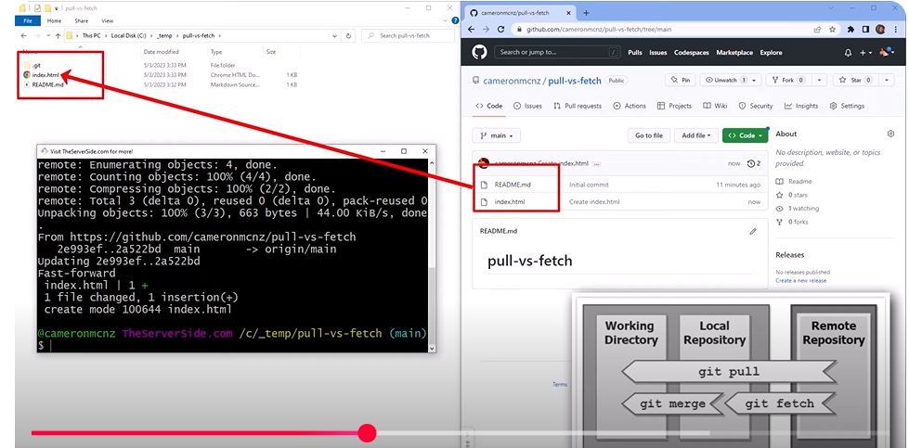

**git fetch** – it will move the new changes from Remote Repo to Loca Repository

**git merge-** download and transfer changes from local repo to working directory

**(Working directory is the project we are working in selenium )**

In Postman, how do you delete a variable after test execution is finished?

**postman.clearEnvironmentVariable("key")**

What is the difference between Comparable and Comparator?

**Given an SQL table, find the second-largest salary of an employee.**

SELECT MAX(SALARY) FROM Employee WHERE SALARY < (SELECT MAX(SALARY) FROM Employee);

**Company based Questions**

**Different between Union and Union All?**

**What are the various types of Classes in Java?**

**What is Singleton Class in Java?**

**How to connect to database using selenium?**

**In selenium 4 which of the following method allow us to take specific web element?**

**Which component of selenium is most important?**

**What is Union?**

Union command contains **2 or more select statements**  
Combines the tables with select statements

Gives distinct values

**What is Union ALL?**

Unionall command **contains 2 or more select statements**

Gives duplicate values also

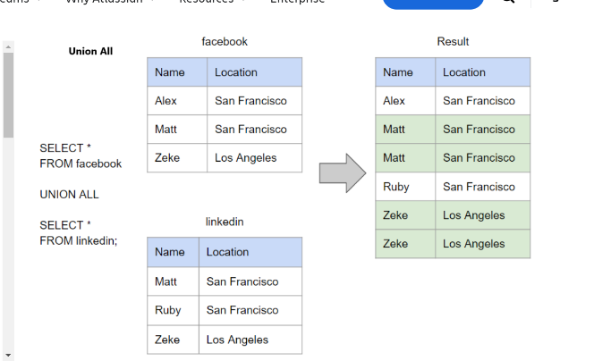

**What are the various types of Classes in Java?**

1. Static, Final, Abstract, Concrete and Singleton Class.

**What is Singleton Class in Java?**

* In object-oriented programming, a singleton class is a class that can have only one object (an instance of the class) at a time.

**How to connect to database using selenium?**

To use Selenium Webdriver for Database testing you need **JDBC (“Java Database Connectivity”).**

JDBC (Java Database Connectivity) is **a SQL level API that allows you to execute SQL statements**

**JDBC API provides the following classes and interfaces**

* Driver Manager
* Driver
* Connection
* Statement
* ResultSet
* SQLException

**3 Steps needed for DB testing**

Step 1) **Make a connection to the Database**

**DriverManager.getConnection(URL, "userid", "password" )**

 the code to create connection looks like

**Connection con = DriverManager.getConnection(dbUrl,username,password);**

You also need to load the JDBC Driver using the code

**Class.forName("com.mysql.jdbc.Driver");**

Step 2) **Send Queries to the Database**

**Statement stmt = con.createStatement();**

**stmt.executeQuery(select * from employee;);**

Step 3) **Process the results**

Results from the executed query are stored in the ResultSet Object.

**Difference between Data Table and Scenario and Examples keyword:**

**DataTables:**

* Data Table works only for the single step below which it is defined rather than the entire scenario
* Test Data is directly specified below the particular step in a Scenario and no separate keyword is needed to define the test data. It doesn’t necessarily have a Header row either

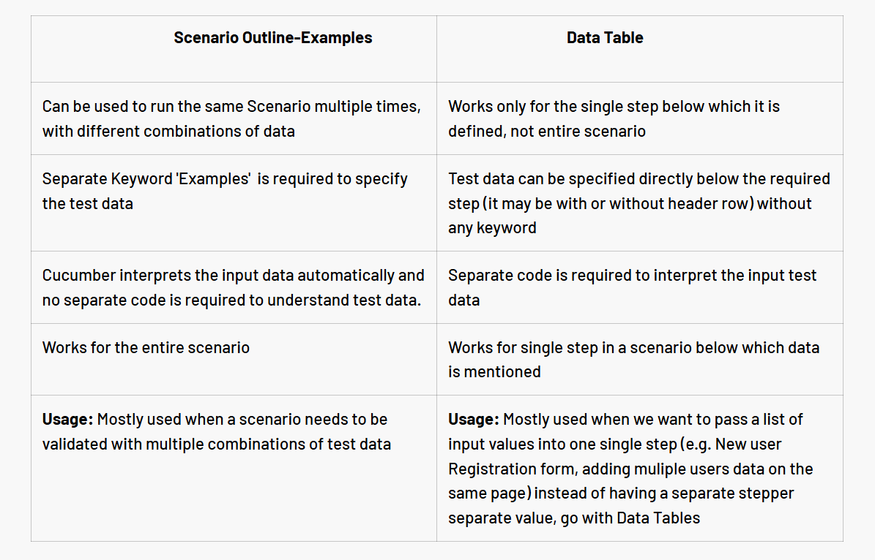

**In selenium 4 which of the following method allow us to take specific web element?**

* **getscreenshotAS()** method in selenium4 used for specific web element

**Which component of selenium is most important?**

* Selenium WebDriver
* Selenenium IDE
* Selenium Grid

**which exception is thrown when delay in loading of the webelement?**

* **Element Not Visible Exception“.** This appears when a particular web element with which WebDriver has to interact, is delayed in its loading.